Year 5 – Maths Home Learning
Autumn Term 2
This term, please practise with your child:
- Multiply and divide numbers by 10, 100 or 1000.
- Know by heart all the squares of numbers between 1 and 12.
- Recognise and use cube numbers and notation.
- Recall prime numbers up to 19.
- Find all factor pairs.

Key Vocabulary
factor | a whole number that divides exactly into another number.
factor pair | a pair of numbers multiplied together to form another  number called their product
prime numbers | a number that has exactly two factors; a number that can only be divided evenly by itself and one. (e.g. 2, 3, 5, 7, 11, 13, 17, 19)
square numbers | a number which can be represented in the shape of a square; a number that results from multiplying an integer by itself (e.g 4, 9, 16, 25, 36)
cube numbers | a number multiplied by itself and again  (e.g. 2³ = 2 x 2 x 2 = 8, 2 cubed = 8)

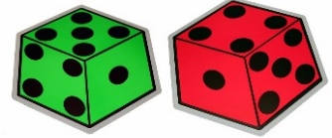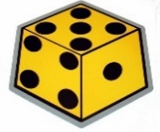

Formal Methods
Column Addition  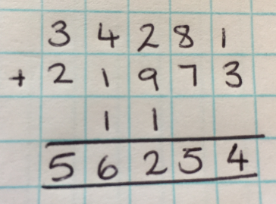 | Column Subtraction  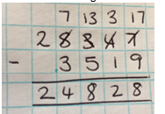
Short Multiplicaiton  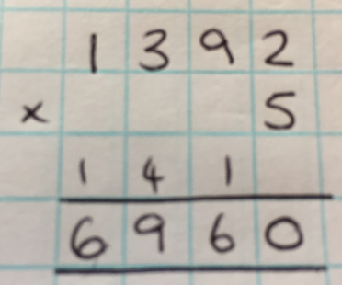 | Long Multiplication  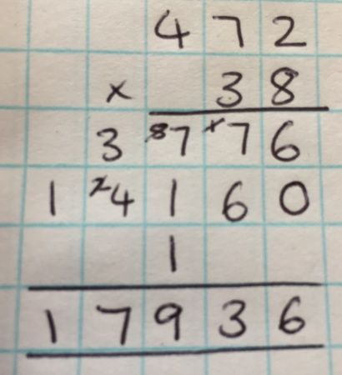

Times Tables
This term Year 5 will be revising 8x and 7x tables
1 x 8 = 8  2 x 8 = 16  3 x 8 = 24  4 x 8 = 32  5 x 8 = 40  6 x 8 = 48  7 x 8 = 56  8 x 8 = 64  9 x 8 = 72  10 x 8 = 80  11 x 8 = 88  12 x 8 = 96 | 1 x 7 = 7  2 x 7 = 14  3 x 7 = 21  4 x 7 = 28  5 x 7 = 35  6 x 7 = 42  7 x 7 = 49  8 x 7 = 56  9 x 7 = 63  10 x 7 = 70  11 x 7 = 77  12 x 7 = 84

The school has subscribed to Times Tables Rock Stars (TTRS). TTRS is an online platforms to help your child practise times tables facts at home. TTRS be downloaded as app on your phone or tablet. Your child has a username and password. This is stuck in their reading record

Maths Games to play at home!
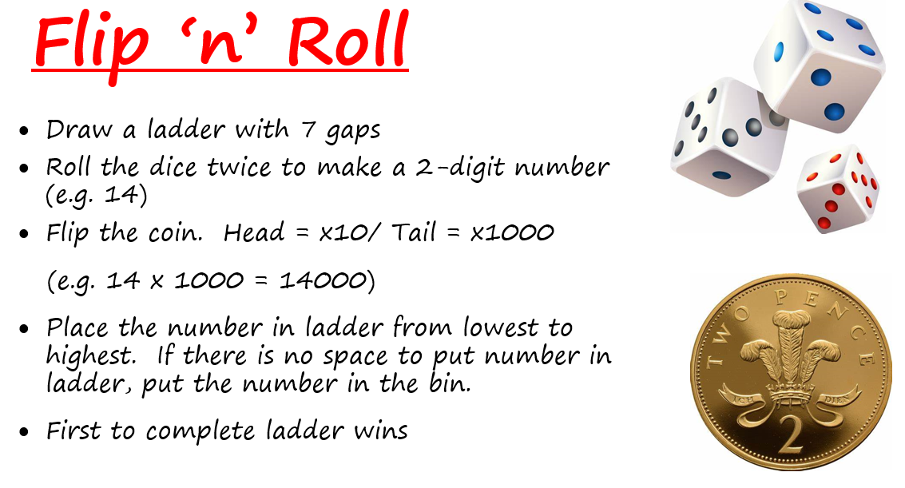
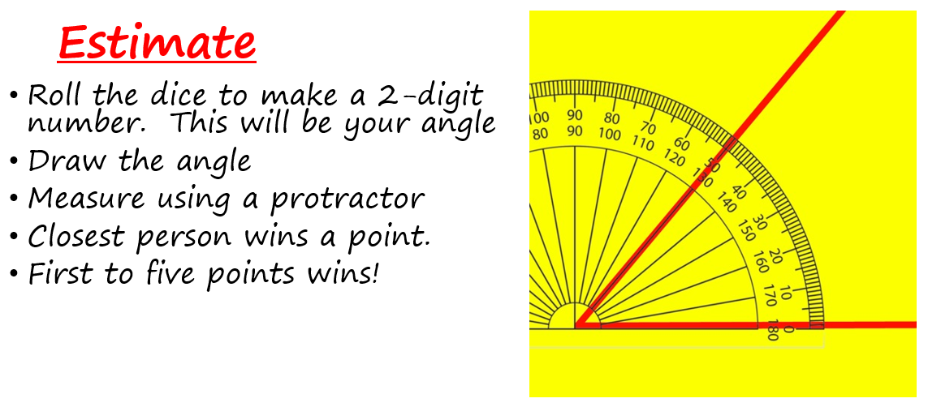
You can play this game online too! Estimating angles | NRICH (maths.org)

For more game ideas go to the school website for the ‘Bare Necessities’ game packs https://stratford-sub-castle.wilts.sch.uk/maths-at-home/

