Year 5 – Maths Home Learning
Summer Term 6
This term, please practise with your child:
- Know facts linked to metric ↔ imperial
  - 1 inch is approximately 2.5 centimetres
1 inch ≈ 2.5 cm
  - 1 kilogram is approximately 2 pounds
1 kg ≈ 2 lbs
  - 1 pint is approximately 560ml
1 pint ≈ 560ml

Recap on geometry facts from Year 4
- Recognise regular polygons
- Name types of triangles (isosceles, equilateral and scalene)
- Name types of quadrilaterals (parallelogram, rhombus and trapezium)
Key Vocabulary
polygon | a 2D shape with straight edges
regular polygon | a polygon with the same size length edges and internal angles
irregular polygon | a polygon with different size length edges and internal angles
quadrilateral | a four sided 2D shape
Types of Triangles (isosceles, equilateral and scalene)
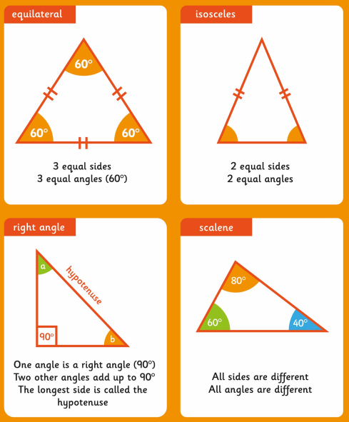
Types of Quadrilaterals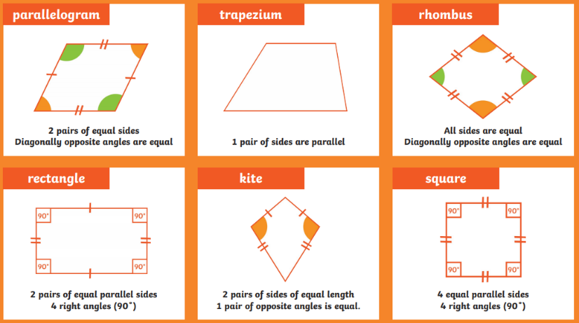

Top Tips!
The secret to success is practising little and often. Can you practise these facts on your walk or drive to school?
Fact of the day - you don’t need to learn there all at once.
‘Free facts’ – If you know that 6 + 4 = 10 then you know that 60 + 40 = 100; 0.6 + 0.4 = 1; 20 – 4 = 16.
Times Tables
This term Year 5 will be revising all times tables up to 12 x 12.
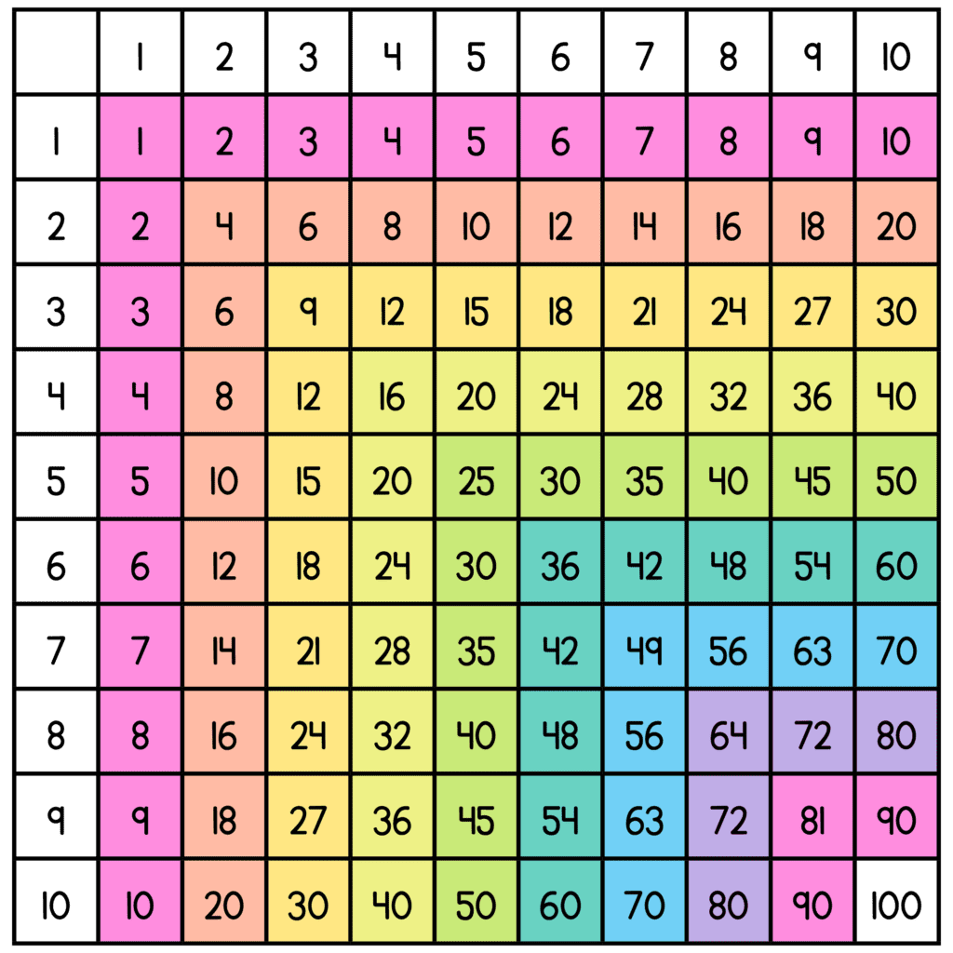

Maths Games to play at home!
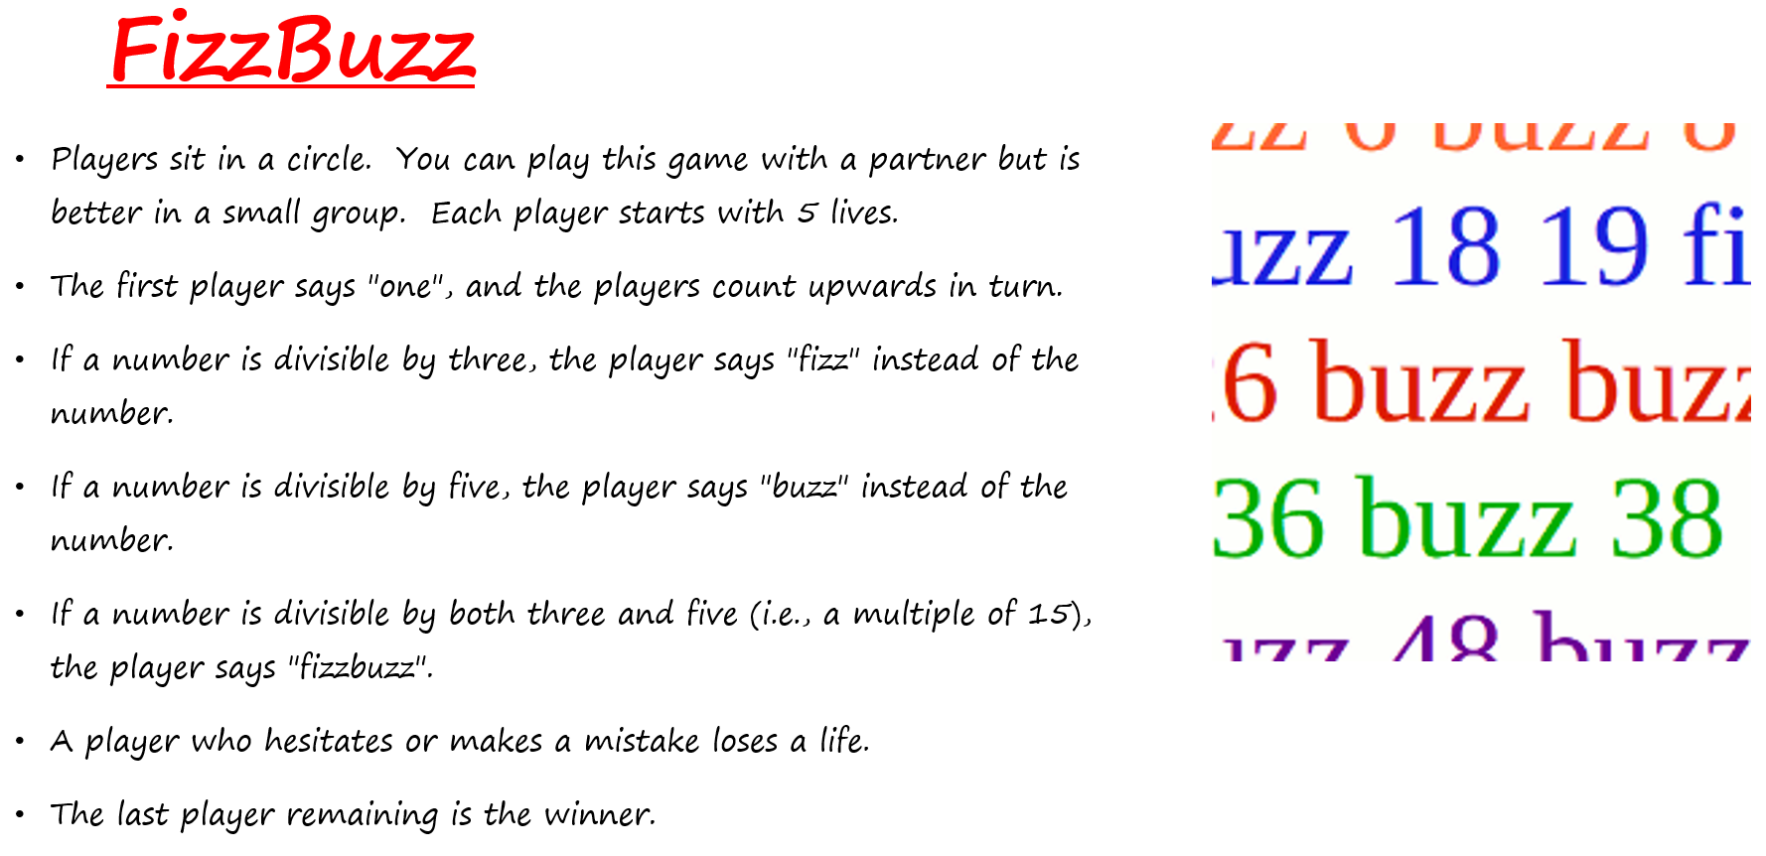
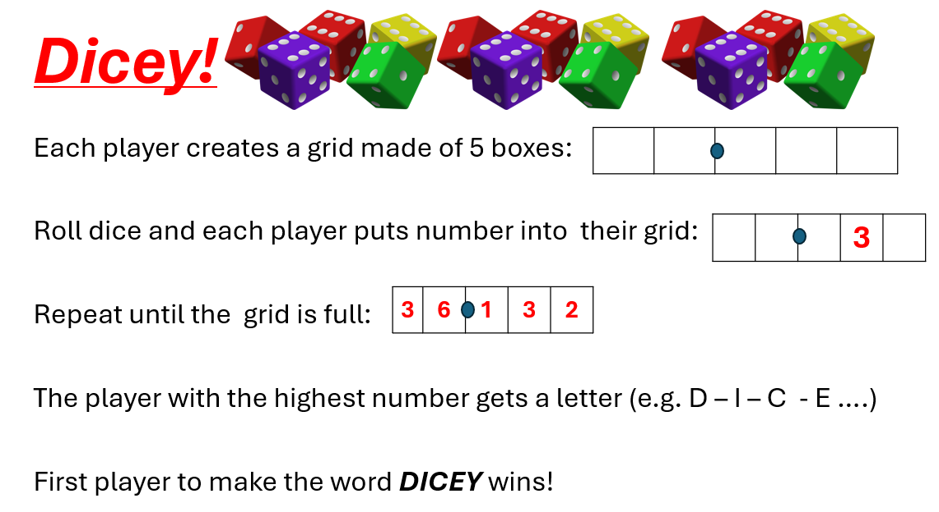
For more game ideas go to the school website for the ‘Bare Necessities’ game packs https://stratford-sub-castle.wilts.sch.uk/maths-at-home/

