EYFS – Maths Home Learning Ideas
Summer Term 6
This term, please practise with your child:
- Quick recall of pairs of numbers to make 5 - 10
- Recognise and name common 2D shapes (circle, square, triangle and rectangle)
- Say their birthday
Please continue to practise:
- Counting forwards in 1’s to 10
- Counting backwards in 1s from 10
- Ordering numbers to 10
- Days of the week

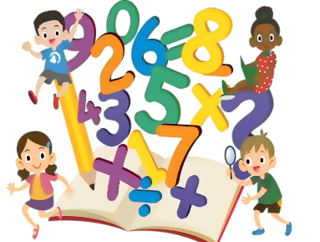
Here are some ideas to help you do this:
 | Further explanation / Ideas of how to practise
Quick recall of pairs of numbers to make 5 - 10 | Make number using objects – split into two groups  Make number using fingers – show as 5 fingers and 2 fingers
Recognise and name common 2D shapes (circle, square, triangle and rectangle) | Go on a shape treasure hunt  Look at shapes in the environment and count how many sides and corners they have, e.g. a square has 4 sides and 4 corners
Say their birthday | Practise saying when their birthday is

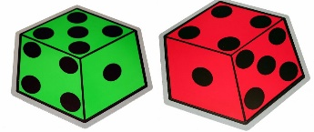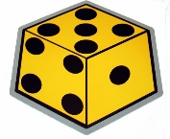

Online Activities
The school has subscribed to NumBots. NumBots is an online platforms to help your child practise maths facts at home. They both can be downloaded as apps on your phone or tablet Your child has a username and password. This is stuck in their reading record
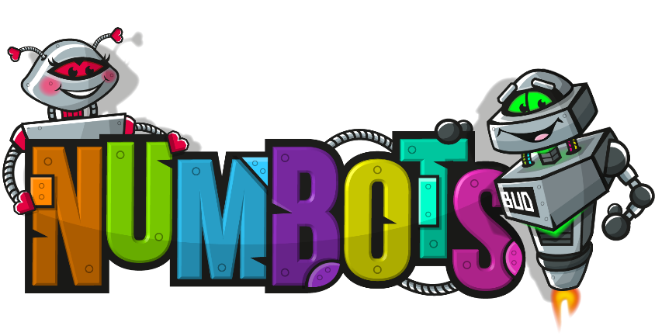
A website packed full of useful Maths and English games.  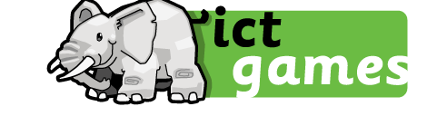 | Numberblocks! Watch and play games with the Numberblocks.  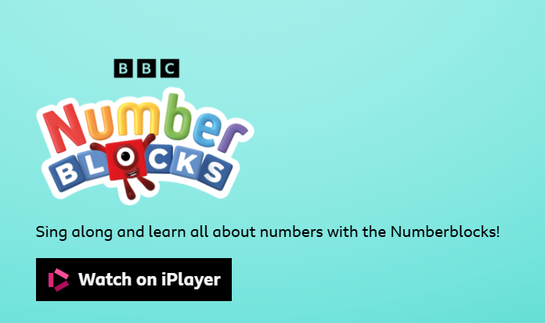

Maths Games to play at home!
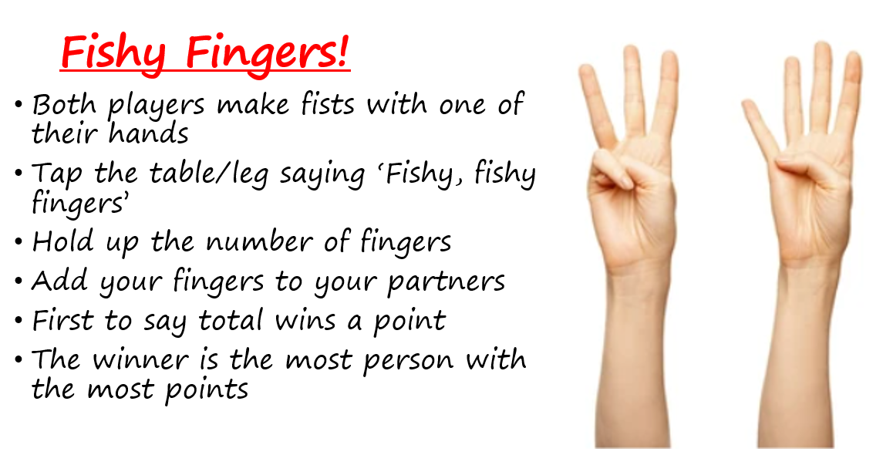

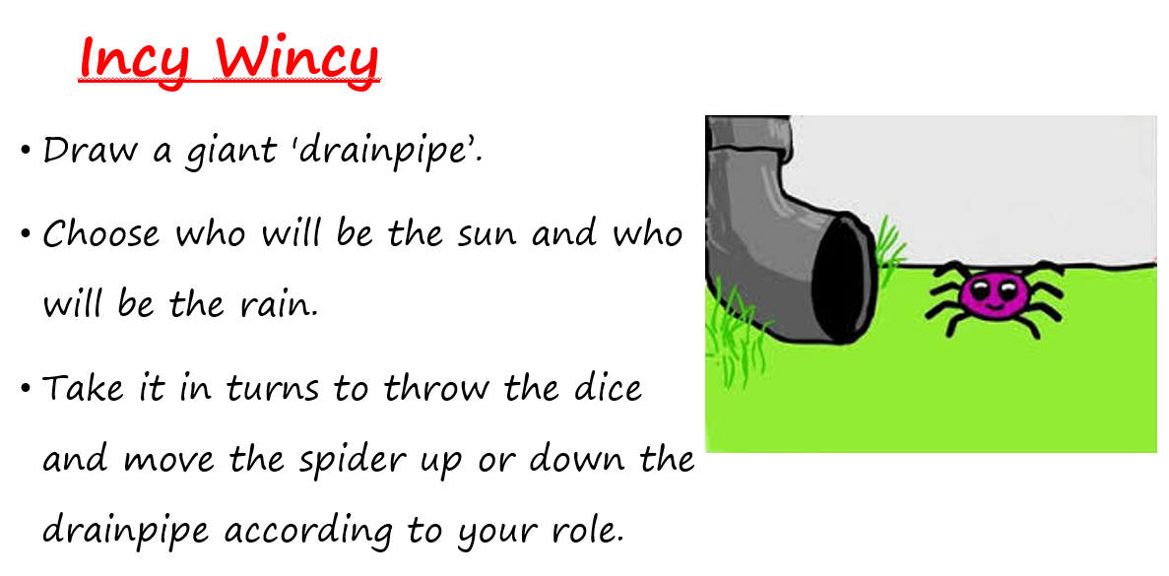
For more game ideas go to the school website for the ‘Bare Necessities’ game packs https://stratford-sub-castle.wilts.sch.uk/maths-at-home/

