Year 1 – Maths Home Learning Ideas
Spring Term 4
This term, please practise with your child:
- Say 1 more or 1 less than a given number to 20
- Say 2 more or 2 less than a given number to 20
Please continue to practise:
- Know pairs of numbers (number bonds) to make 7 (e.g. 3 + 4) Subtraction facts for bonds to 7 (e.g. 7-2 = 5)
- Know pairs of numbers (number bonds) to make 9 (e.g. 2 + 7) / Subtraction facts for bonds to 9 (e.g. 9 - 5 = 4)

Top Tips!
- The secret to success is practising little and often. Can you practise these facts on your walk or drive to school?
- Fact of the day - you don’t need to learn there all at once.
- ‘Free facts’ – If you know that 6 + 4 = 10 then you know that 10 – 4 = 6
Key Vocabulary
number bond | two numbers added together to make another number (e.g 2 + 3 = 5)
partitioning | splits (partitions) numbers into smaller parts
Here are some ideas to help you do this:
 | Further explanation / Ideas of how to practise
Number bonds. | Number bonds – two numbers that add together to make a whole. e.g. 5 = 1 +4 or 3+ 2  Play games matching pairs with playing of numbers together to make a bond (ie. 5 and 2 to make 7); roll a dice and say the other number (the complement) to make the bond.  Use pegs and a coat hanger to create the number bonds  Create a rainbow of the ‘bonds’
Subtraction facts | Subtraction facts for number bonds – the reversal, e.g. 5 – 2 = 3, 5 – 1 = 4  Play ‘Kims’ game with number bonds – needs to be quick!
Say 1 more or 1 less than a given number to 20  Say 2 more or 2 less than a given number to 20 | Write the numbers 1 to 20 on pieces of card. Turn over quickly. What is 1 less than 18? This needs to be quick recall!
Online Activities
The school has subscribed to NumBots. NumBots is an online platforms to help your child practise maths facts at home. They both can be downloaded as apps on your phone or tablet Your child has a username and password. This is stuck in their reading record
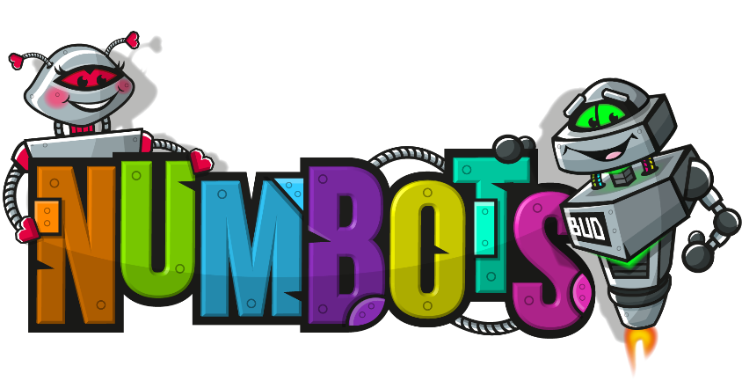
A website packed full of useful Maths and English games.  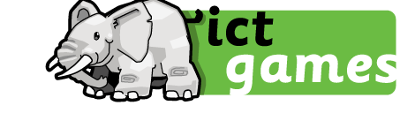 | Numberblocks! Watch and play games with the Numberblocks.  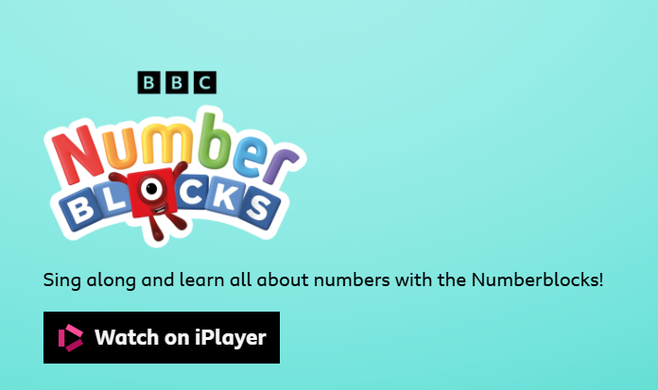

Maths Games to play at home!
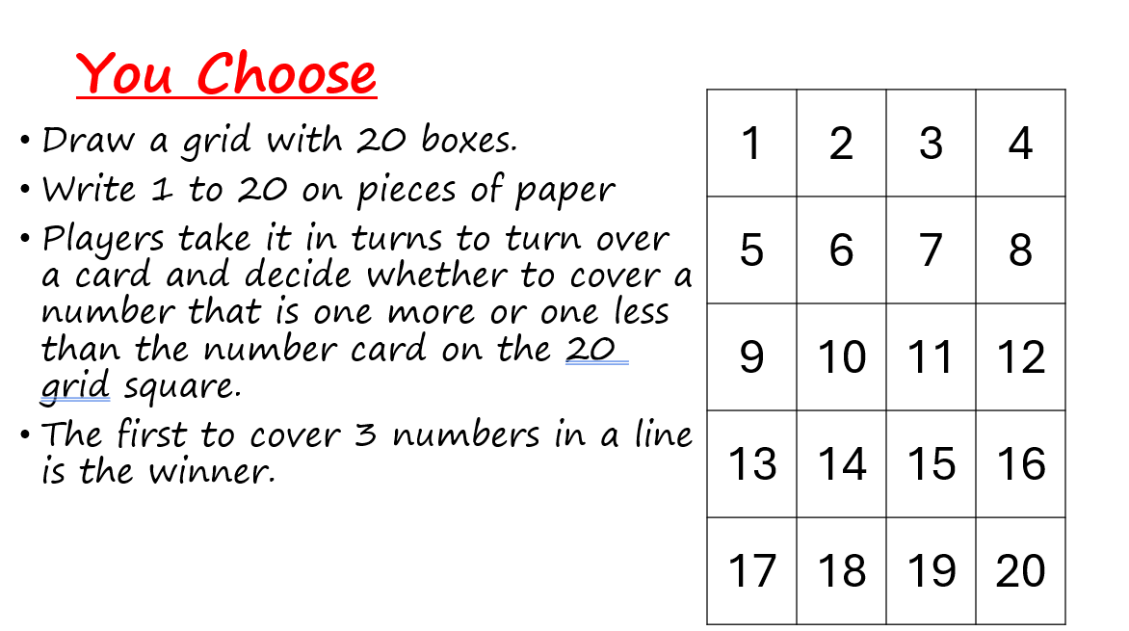
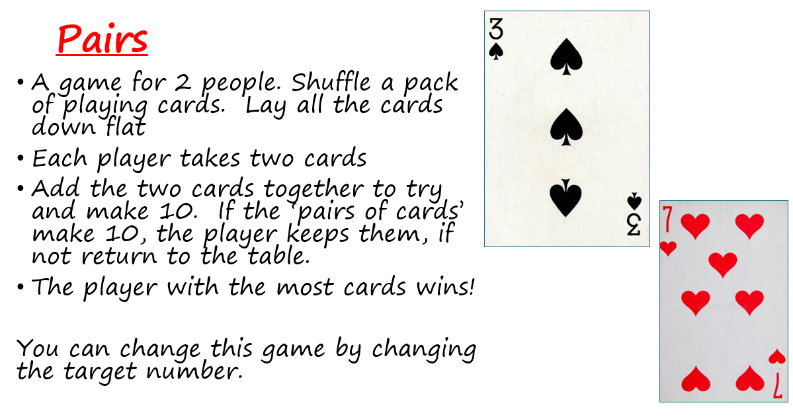

For more game ideas go to the school website for the ‘Bare Necessities’ game packs https://stratford-sub-castle.wilts.sch.uk/maths-at-home/

