EYFS – Maths Home Learning Ideas
Spring Term 4
This term, please practise with your child:
- Ordering numbers up to 8
- Know 7 the different pairs of numbers to make 7 (e.g. 6 and 1, 5 and 2, 4 and 3)
Please continue to practise:
- Counting forwards in 1’s to 10
- Counting backwards in 1s from 10
- Days of the week

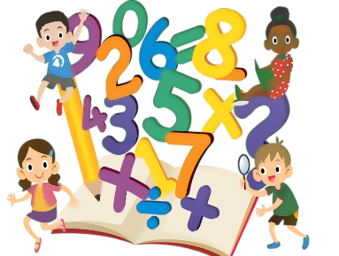
Here are some ideas to help you do this:
 | Further explanation / Ideas of how to practise
Know 7 the different pairs of numbers to make 7 (e.g. 6 and 1, 5 and 2, 4 and 3) | Make 7 using objects – split into two groups  Make 7 using fingers – show as 5 fingers and 2 fingers
Ordering numbers up to 8 | Write the numbers on pieces of paper or use playing cards and put in order.
Count forwards in 1’s to 10 | Regular practice counting anything and everything!  Sing counting songs (eg, 1,2,3,4,5, once I caught a fish alive!)  How many marbles are in this jar?  How many socks are in the laundry basket?  Use storybooks – count the number of eyes you can see on the page / count the number of trees you can see on the page  Counting backwards is just as important as counting forwards!
Count backwards in 1s from 10

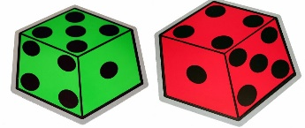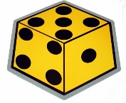

Online Activities
The school has subscribed to NumBots. NumBots is an online platforms to help your child practise maths facts at home. They both can be downloaded as apps on your phone or tablet Your child has a username and password. This is stuck in their reading record
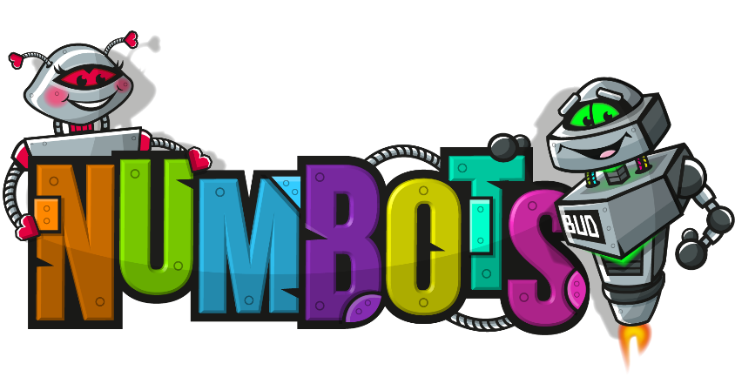
A website packed full of useful Maths and English games.  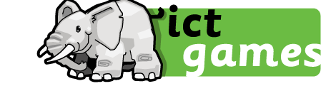 | Numberblocks! Watch and play games with the Numberblocks.  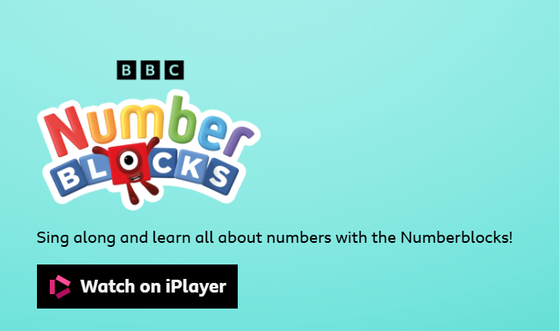

Maths Games to play at home!
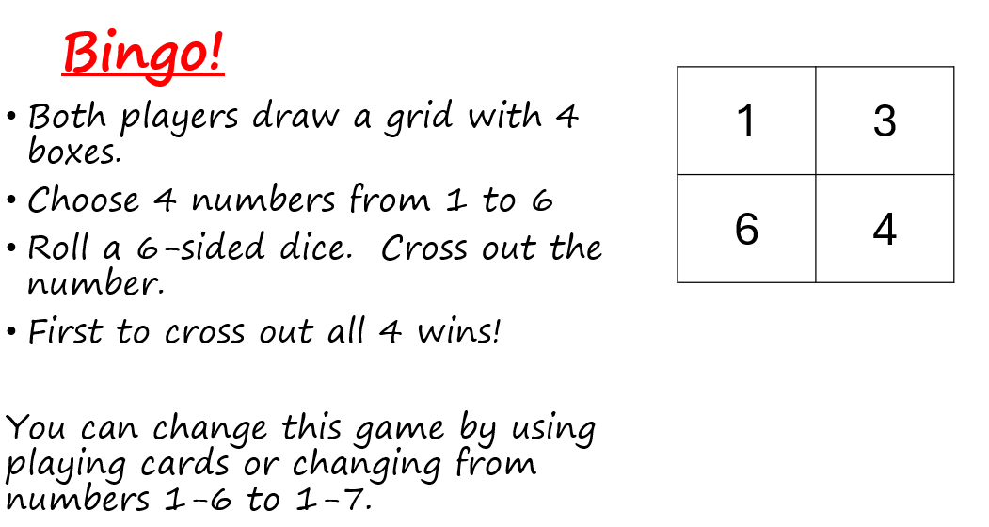
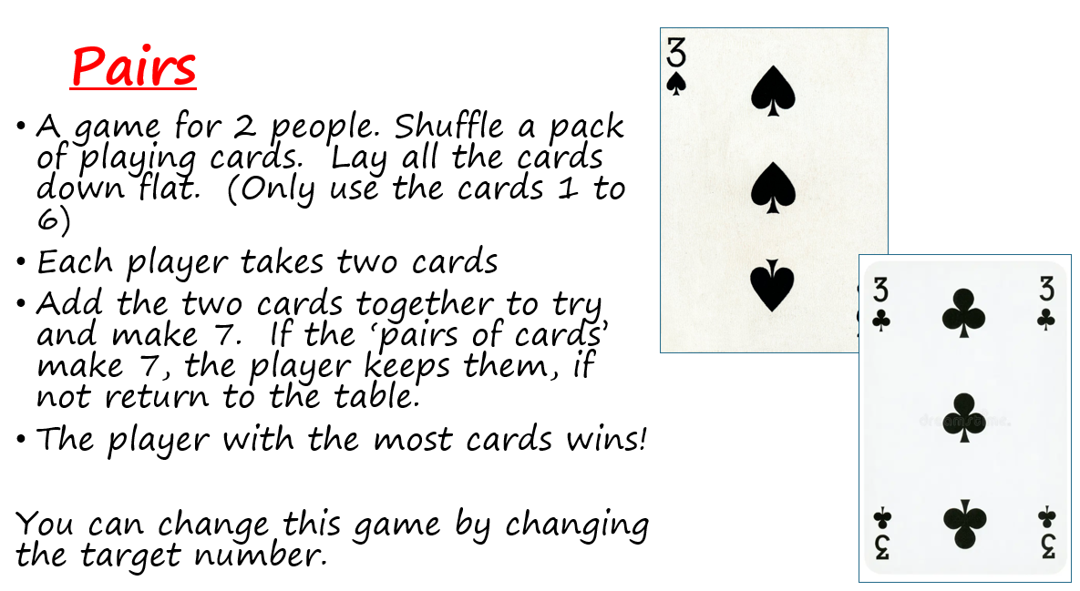
For more game ideas go to the school website for the ‘Bare Necessities’ game packs https://stratford-sub-castle.wilts.sch.uk/maths-at-home/

