Year 5 – Maths Home Learning
Spring Term 3
This term, please practise with your child:
- Multiply and divide numbers by 10, 100 or 1000.
- Know that 10 tenths are equivalent to 1/ Know that 1 is 10 times the size of 0.1
- Know that 100 hundredths are equivalent to 1 one / Know that 1 is 100 times the size of 0.01
- Know that 10 hundredths are equivalent to 1 tenth/ Know that 0.1 it 10 times the size of 0.01

Recap measure facts from Year 4
Measure
mm ↔ cm | 10mm = 1cm
cm ↔ m | 100cm = 1m
cm ↔ m | 50 cm = ½ m
cm ↔ m | 25cm = ¼ m
m ↔ km | 1000m = 1km
m ↔ km | 500m = ½ km
m ↔ km | 250m = ¼ km

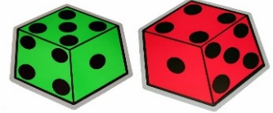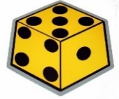

Key Vocabulary
factor | a whole number that divides exactly into another number.
tenth | A fraction, one part of 10 equal parts.
hundredth | A fraction, one part of 100 equal parts.
equivalent | equal in value,

Maths Fact | Further explanation / Ideas of how to practise
Multiply and divide numbers by 10, 100 or 1000. | e.g. 24 x 1000 = 24,000 1.3 x 100 = 130
Multiply and divide numbers by 10, 100 or 1000. | 53 ÷ 1000 = 0.053 3.4 ÷ 100 = 0.034
Know that 10 tenths are equivalent to 1/ Know that 1 is 10 times the size of 0.1 | “10 tenths is equal to 1 one.”  “1 is 10 times the size of one-tenth.”  “One-tenth is 10 times the size of one-hundredth.”
Know that 100 hundredths are equivalent to 1 one / Know that 1 is 100 times the size of 0.01 | “1 is 100 times the size of one-hundredth.”  “100 hundredths is equal to 1 one.”
Know that 10 hundredths are equivalent to 1 tenth/ Know that 0.1 it 10 times the size of 0.01 | “10 hundredths is equal to 1 tenth.”

=

Times Tables
This term Year 5 will be revising 7x and 9x tables
1 x 7 = 7  2 x 7 = 14  3 x 7 = 21  4 x 7 = 28  5 x 7 = 35  6 x 7 = 42  7 x 7 = 49  8 x 7 = 56  9 x 7 = 63  10 x 7 = 70  11 x 7 = 77  12 x 7 = 84 | 1 x 9 = 9  2 x 9 = 18  3 x 9 = 27  4 x 9 = 36  5 x 9 = 45  6 x 9 = 54  7 x 9 = 63  8 x 9 = 72  9 x 9 = 81  10 x 9 = 90  11 x 9 = 99  12 x 9 = 108
Formal Methods
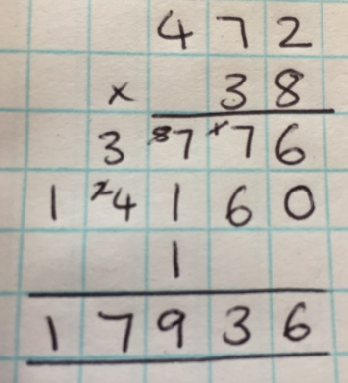 | 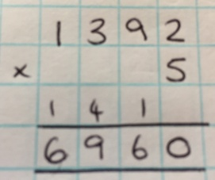
 | 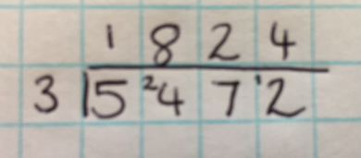
Maths Games to play at home!
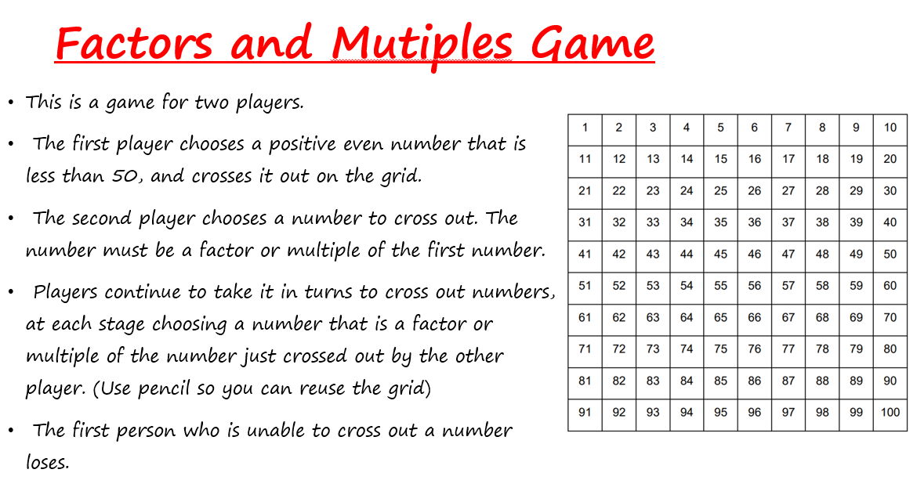

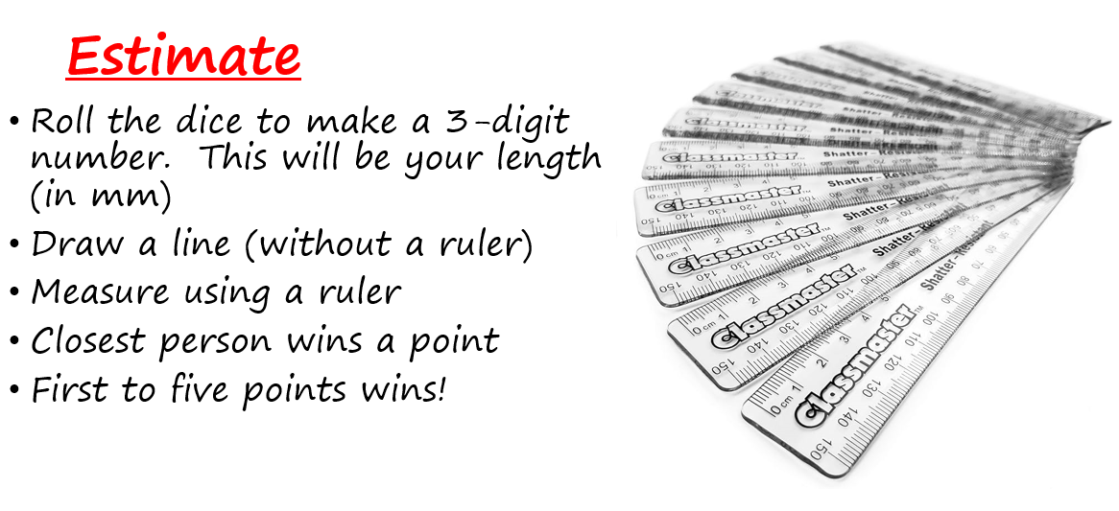


The school has subscribed to Times Tables Rock Stars (TTRS). Your child has a username and password. This is stuck in their reading record

